Slide-5. Cost Estimation & Quality Assurance
Q1. What is Software Cost Estimation? Why is it important?
Software cost estimation is the systematic process of forecasting the amount of effort (person-months), time (schedule), staffing requirements, and monetary resources needed to complete a software development project successfully. It is performed at various stages using available requirements, historical data from past projects, expert judgment, assumptions, constraints, and risk assessment.
Importance of Cost Estimation
- Enables organizations to prepare realistic budgets and secure adequate funding.
- Facilitates accurate project scheduling, resource allocation, and milestone planning, thereby preventing delays.
- Supports early identification of technical and managerial risks, allowing proactive mitigation measures.
- Minimizes the probability of cost overruns, excessive rework, scope creep, and ultimate project failure.
- Builds stakeholder confidence and transparency by providing justifiable quotes to clients and management.
- Serves as a baseline for monitoring actual expenditure against planned costs throughout the project lifecycle.
Accurate and reliable cost estimation is a cornerstone of successful project management and directly influences profitability and customer satisfaction.

Q2. Explain different components of software cost.
The total cost of a software project comprises multiple interrelated components:
Hardware and Software Cost
- Acquisition of development machines, servers, testing environments, networking infrastructure, and cloud services.
- Purchase or licensing of compilers, IDEs, testing tools, version control systems, and third-party libraries.
- Ongoing costs for hardware/software maintenance, upgrades, and security patches.
Travel and Training Cost
- Expenses for on-site client visits, requirement gathering workshops, user acceptance testing, and training sessions.
- Professional training programs, certifications, and skill enhancement courses for team members on new technologies.
Effort Cost
- Salaries, bonuses, and benefits of analysts, designers, developers, testers, quality assurance engineers, and project managers.
- Organizational overheads such as office space, electricity, internet bandwidth, insurance, and administrative support.

Other Costs
- Documentation, configuration management, deployment, and post-delivery maintenance costs.
- Contingency reserves for unforeseen risks and change requests.

Among all components, effort cost typically constitutes 70–85% of the total cost because software development remains predominantly a human-intensive activity.

Q3. Explain Algorithmic Cost Modeling.
Algorithmic cost modeling uses empirical mathematical equations derived from large datasets of completed projects to predict effort, duration, and cost. These models treat software size (lines of code, function points, etc.) and a set of cost drivers as input parameters to produce quantitative estimates. Popular examples include COCOMO, SLIM, and ESTIMACS.

Key Characteristics
- Relies on historical data and statistical regression for calibration.
- Expresses effort as a non-linear function of size (usually exponential) because complexity grows faster than size.
- Incorporates cost drivers such as product complexity, personnel capability, hardware constraints, and schedule pressure.
- Generates not only effort but also development time, staffing profile, and productivity metrics.

Advantages
- Provides objective, repeatable, and comparable estimates.
- Can be calibrated with organization-specific historical data for higher accuracy.

Challenges
- Requires accurate size estimation early in the lifecycle when requirements are incomplete.
- Sensitivity to the choice and rating of cost drivers, which still involve subjective judgment.
- Less effective for radically new technologies or domains with insufficient historical data.

Despite limitations, algorithmic models remain the most widely accepted and reliable estimation technique in the industry.

Q4. What is the COCOMO model? Describe its three modes.
COCOMO (Constructive Cost Model), developed by Barry Boehm in 1981, is an algorithmic model that estimates effort in person-months and development time in months using thousands of lines of code (KLOC) as the primary size metric.

The basic equation is Effort = a × (KLOC)^b × EAF, where EAF is the Effort Adjustment Factor derived from 15 cost drivers.

Three Hierarchical Modes of COCOMO 81:
1. Organic Mode
- Small-to-medium projects (<50 KLOC), stable requirements, experienced teams, and flexible processes.
- Example: In-house business applications.
- Lowest values of exponents (b ≈ 1.05), hence least effort escalation with size.

2. Semi-Detached Mode
- Intermediate projects (50–300 KLOC) with mixed team experience and moderate rigidity in requirements.
- Example: Transaction processing systems.
- Exponent b ≈ 1.12.

3. Embedded Mode
- Large projects (>300 KLOC) with tight hardware, operational, and regulatory constraints.
- Example: Real-time embedded systems, avionics software.
- Highest exponent (b ≈ 1.20), reflecting significant complexity growth.

Each mode uses different coefficients (a, b) and different nominal schedules, making COCOMO adaptable to diverse project environments.

Q5. What is COCOMO II? How is it different from COCOMO 81?
COCOMO II (2000) is the updated and significantly enhanced successor to the original 1981 model, designed for modern development paradigms such as object-oriented programming, reuse, spiral lifecycle, and rapid application development.

Key Improvements and Differences from COCOMO 81:
- Size metrics expanded to include Function Points, Object Points, and Source Lines of Code.
- Supports application composition, early design, reuse, and post-architecture models.
- 17–23 cost drivers (instead of 15) with revised rating scales and new drivers like personnel continuity, multi-site development, and required reusability.
- Scale factors replace the three rigid modes with a continuous exponential factor based on five attributes (precedentedness, flexibility, risk resolution, team cohesion, process maturity).
- Provides separate models for early prototyping, early design, and detailed post-architecture estimation.
- Better calibration with over 161 modern projects.

COCOMO II delivers significantly higher accuracy for contemporary software engineering practices.

Q6. What is Quality Assurance? Why is it important?
Quality Assurance (QA) is a planned and systematic set of activities performed throughout the software development lifecycle to ensure that processes are defined, followed, and continuously improved so that the delivered product conforms to established technical requirements and user expectations. Unlike quality control (defect detection), QA focuses on defect prevention through process improvement.

Importance of QA
- Builds quality into the product from the beginning rather than inspecting it in at the end.
- Detects process weaknesses early, thereby reducing defects, rework, and overall development cost (cost of quality).
- Increases reliability, usability, performance, security, and maintainability of the software.
- Enhances customer satisfaction and organizational reputation, leading to repeat business and market competitiveness.
- Provides objective evidence for audits, certifications (ISO, CMMI), and regulatory compliance.
- Facilitates predictable schedules and budgets by minimizing surprises and crisis management.

Effective QA transforms software development from an ad-hoc activity into a repeatable engineering discipline.

Q7. Explain Six Sigma for Software Engineering.
Six Sigma is a data-driven quality improvement methodology aimed at reducing process variation and achieving near-perfect quality (maximum 3.4 defects per million opportunities). In software engineering, it adapts the DMAIC framework to improve development and testing processes.

DMAIC Phases in Software Context:
- Define: Identify customer-critical requirements (CTQs), project goals, and defect definitions.
- Measure: Collect baseline metrics such as defect density, cycle time, effort variance, and requirements stability.
- Analyze: Use statistical tools (Pareto charts, fishbone diagrams, regression) to identify root causes of defects (e.g., ambiguous requirements, poor reviews).
- Improve: Implement solutions such as enhanced review checklists, automated testing, or better requirement management tools.
- Control: Establish control charts, dashboards, and standard operating procedures to sustain gains.

Additional tools: Design for Six Sigma (DFSS/DMADV) for new products, Voice of Customer (VOC) analysis, and SIPOC diagrams.

Benefits in software: Higher process capability, reduced rework (often 30–50%), improved predictability, and lower maintenance costs.

Q8. Explain ISO 9000 Quality Standards.
ISO 9000 is a family of international standards (ISO 9000:2015 fundamentals, ISO 9001:2015 requirements, ISO 9004:2018 guidelines) that provide a generic quality management system framework applicable to any organization regardless of size or industry.
Seven Quality Management Principles:
1. Customer focus
2. Leadership
3. Engagement of people
4. Process approach
5. Improvement
6. Evidence-based decision making
7. Relationship management
Key Requirements of ISO 9001:2015 (Software Context):
- Establishing a quality policy and measurable objectives.
- Documented information (procedures, work instructions, records).
- Risk-based thinking and preventive actions.
- Management review, internal audits, and corrective actions.
- Control of externally provided processes (outsourced development).

Certification demonstrates that an organization consistently provides products and services that meet customer and regulatory requirements, enhancing global credibility.
Q9. Explain Capability Maturity Model (CMM) and its five levels.
The Capability Maturity Model for Software (SW-CMM), later evolved into CMMI, describes five evolutionary levels of process maturity in software organizations:
Level 1 – Initial: Processes are ad-hoc, chaotic, and hero-driven; success depends on individual effort.
Level 2 – Repeatable: Basic project management processes (planning, tracking, requirements management, configuration management) are established; past successes can be repeated.
Level 3 – Defined: Organization-wide standardized processes are documented, trained, and followed; engineering and management processes are integrated.
Level 4 – Managed: Detailed quantitative metrics are collected; processes are predictable with statistical control (e.g., defect rates within limits).
Level 5 – Optimizing: Continuous process improvement using quantitative feedback and innovative ideas; focus on defect prevention and technology adoption.
Higher maturity levels correlate with lower defect rates, better schedule/cost predictability, and higher productivity.

Q10. Difference between ISO 9000 and CMM.
Aspect | ISO 9000 | CMM / CMMI
Scope | Generic – applicable to any industry | Specific to software/system engineering
Focus | Quality management system & certification | Process improvement & maturity assessment
Objective | Meet customer & regulatory requirements | Improve process capability & performance
Structure | Single standard (pass/fail certification) | Five maturity levels (progressive)
Measurement | Qualitative conformance | Quantitative metrics and statistical control
Origin | International Standards Organization | Software Engineering Institute (SEI)
Certification | Third-party certification mandatory | Appraisal (SCAMPI) – not always certified

Organizations often pursue ISO 9001 for market credibility and CMMI for internal process excellence.

Slide-6. Function Oriented Software Design
Q1. What is Software Design? Explain its purpose.
Software design is the creative and technical process of transforming user requirements specified in the Software Requirements Specification (SRS) into a detailed blueprint that describes the system architecture, components, interfaces, data structures, algorithms, and control flow necessary for implementation.

Purpose of Software Design
- To bridge the gap between requirements and coding by providing a clear, implementable structure.
- To manage complexity through decomposition and abstraction.
- To enable parallel development, independent testing, and easier maintenance.
- To identify and resolve design risks early, reducing costly changes during coding or testing.
- To serve as the primary communication and review artifact among stakeholders, developers, and testers.

Good design is the foundation for producing high-quality, maintainable, and scalable software systems.

Q2. What is Function-Oriented Design?
Function-Oriented Design (also called Structured Design or Procedural Design) is a traditional design paradigm that views a software system as a collection of functions or procedures that transform inputs into outputs. The system is decomposed into a hierarchy of functions, each performing a specific, well-defined task with minimal side effects.
Key Characteristics
- Data flow is central; functions are organized according to “what the system does.”
- Uses Data Flow Diagrams (DFDs) and Structure Charts as primary representation tools.
- Emphasis on functional decomposition, cohesion, and coupling.
- Control flow passes from calling module to called module via parameters and return values.

Advantages
- Intuitive for procedural languages (C, COBOL, Fortran).
- Easy to understand, trace, and debug sequential processing.
- Supports high cohesion within modules and low coupling between modules.
Limitations
- Less suitable for systems with complex data relationships or frequent changes in functionality.

Q3. What are Design Methodologies? Explain.
Design methodologies are systematic, step-by-step frameworks that guide designers from requirements to a complete design using defined notations, heuristics, and verification techniques. Examples include Structured Analysis/Structured Design (SA/SD), Jackson Structured Programming (JSP), and Yourdon-Constantine method.
Objectives of Design Methodologies
- Reduce arbitrary design decisions and promote disciplined thinking.
- Provide standard graphical and textual notations for unambiguous communication.
- Enforce design quality criteria (high cohesion, low coupling, information hiding).
- Facilitate design reviews, walkthroughs, and traceability to requirements.
- Enable reuse of design patterns and proven solutions across projects.

Q4. Explain objectives of Software Design.
The primary objectives of software design are:
- Correctness: The design must fully satisfy all functional and non-functional requirements.
- Efficiency: Optimal use of computational resources (time, memory, network).
- Flexibility and Extensibility: Easy accommodation of future changes and enhancements.
- Understandability: Design should be clear to developers, testers, and maintainers.
- Reusability: Components should be generic enough for use in other projects.
- Reliability and Safety: Minimize failures and their consequences.
- Maintainability: Low cost and effort for bug fixing and upgrades.
- Portability: Ability to run on different platforms with minimal changes.

Q5. Explain Software Design Principles.
Fundamental principles guiding good function-oriented design:
Abstraction
- Focus on essential features while suppressing unnecessary details at each level.
Refinement
- Stepwise elaboration from high-level design to detailed design (stepwise refinement).
Modularity
- Divide system into cohesive modules with well-defined interfaces.
Cohesion
- Degree to which elements inside a module belong together (aim for high functional cohesion).
Coupling
- Measure of interdependence between modules (aim for low/data coupling).
Information Hiding
- Internal details of a module are hidden; only interface is exposed.
Hierarchy
- Organize modules in layered or tree structure for control and visibility.

Q6. What is Problem Partitioning and Hierarchy?
Problem partitioning is the technique of dividing a complex problem into smaller, manageable sub-problems that can be solved independently. Hierarchy refers to arranging these sub-problems/modules in levels where higher-level modules invoke lower-level ones.
Benefits
- Reduces perceived complexity (divide-and-conquer).
- Enables parallel development by different team members.
- Localizes changes; modification in one module has limited impact.
- Facilitates independent unit testing and integration testing.
- Improves readability and maintainability of the overall system.

Q7. Explain Abstraction in Software Design.
Abstraction is the process of identifying the essential characteristics of an entity while ignoring irrelevant details, thereby reducing complexity and focusing attention on the current level of design.

Types of Abstraction
- Procedural (Functional) Abstraction: Specifies what a function does without revealing how (e.g., sort(list)).
- Data Abstraction: Defines abstract data types (ADT) with operations while hiding representation (e.g., Stack with push/pop).
- Control Abstraction: Hides sequencing details (e.g., iteration constructs, event handling).

Abstraction layers allow designers to work at different levels (system → subsystem → module → procedure) without being overwhelmed by details.

Q8. What is Modularity? Explain its importance.
Modularity is the property of a system that has been decomposed into a set of cohesive, loosely-coupled modules, each with a well-defined interface and single responsibility.

Importance of Modularity
- Supports intellectual manageability; developers can understand one module without knowing all others.
- Enables parallel development and distributed teams.
- Facilitates independent testing and debugging.
- Promotes reuse of modules across projects.
- Limits propagation of errors and simplifies maintenance.
- Allows incremental delivery and easier integration.

Q9. Explain Top-Down and Bottom-Up Approaches.
Top-Down Approach
- Starts with the most abstract level (main function/system overview) and successively refines into detailed modules.
- Ideal when requirements are clear and no reusable components exist.
- Naturally produces a hierarchical structure chart.

Bottom-Up Approach
- Begins by designing and implementing low-level utility modules first, then combines them into higher-level functions.
- Useful when many reusable components or libraries are available.
- Risks designing unnecessary functions or poor overall architecture.

In practice, modern design uses a combination: top-down for overall architecture and bottom-up for reusable components (middle-out approach).

Q10. Explain Structure Charts and their role.
A Structure Chart is a graphical design tool that depicts the hierarchical partitioning of a system into modules, showing:
- Boxes representing modules.
- Arrows indicating calling relationships (control flow).
- Diamonds or special symbols for selection/iteration.
- Data couples (parameters) and control flags on arrows.

Role of Structure Charts
- Visualizes module hierarchy and invocation sequence.
- Enforces design decisions on coupling and cohesion.
- Serves as primary documentation for functional decomposition.
- Helps detect excessive fan-in/fan-out, deep nesting, or improper control flow.
- Guides implementation order and integration testing sequence.

Q11. Explain types of modules in Function-Oriented Design.
Common module categories in structured design:
- Afferent (Input) Modules: Acquire data from external environment (read files, GUI forms, sensors).
- Efferent (Output) Modules: Produce results or reports (display, print, write files).
- Transform Modules: Perform core data processing and conversion (calculation, validation, formatting).
- Coordinate (Control) Modules: Manage sequence, invoke transform modules, handle exceptions.
- Composite/Reusable Modules: Combine multiple functions (e.g., database access layer).

Proper classification leads to a balanced transform-centered or transaction-centered design.

Q12. What is Design Specification? Explain its components.
Design Specification (also called Design Document or Detailed Design) is a comprehensive, formal document that captures all design decisions and serves as the contract between designers and implementers.
Major Components
- Introduction and overview of architecture.
- Structure charts or module hierarchy diagrams.
- Detailed module specifications (purpose, inputs, outputs, processing logic, error handling).
- Interface specifications (parameters, data types, calling sequence).
- Data dictionary and database/file design.
- User interface design (screens, reports).
- Design constraints, assumptions, and rationale.
- Traceability matrix linking design elements to requirements.
- List of reused components and third-party libraries.

Q13. Explain Tabular Design Notation and its purpose.
Tabular design notation includes Decision Tables and Decision Trees used to represent complex conditional logic in a compact, unambiguous format.
Decision Table Structure
- Condition stubs (rows for conditions).
- Action stubs (rows for actions).
- Condition entries (Y/N/-).
- Action entries (X or blank).
- Rules (columns representing unique combinations).

Purpose
- Eliminates ambiguity, overlap, and contradiction in business rules.
- Makes exhaustive testing easier (one test case per rule).
- Simplifies validation by stakeholders.
- Reduces implementation errors in modules with multiple interdependent conditions (e.g., tax calculation, eligibility checking).

Slide-7 Testing
Q1. Explain Verification and Validation in software testing.
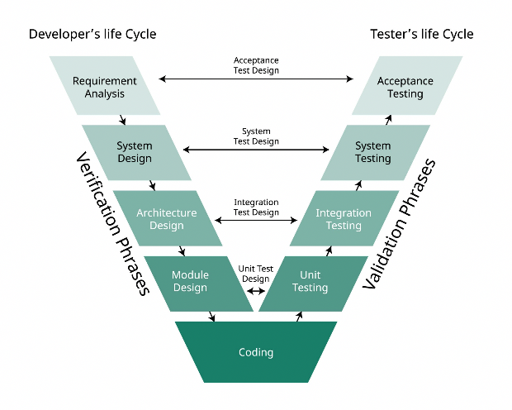
Verification and Validation (V&V) are the two core quality assurance processes in software engineering. Verification checks whether the software is being built correctly by examining intermediate artifacts throughout the development process to confirm strict adherence to specified requirements. It answers “Are we building the product, right?” through static techniques such as reviews, walkthroughs, inspections, and desk-checking. Validation, performed after the product is complete, confirms that the software actually solves the intended business problem and satisfies real user needs in operational conditions. It answers “Are we building the right product?” by executing the system and observing actual behavior against expected outcomes. When combined, verification prevents errors early while validation ensures customer satisfaction, significantly enhancing reliability, reducing post-release failures, and minimizing costly rework. Together they form a complete quality gate before the software is delivered.

Q2. What are the goals of software testing? Explain.
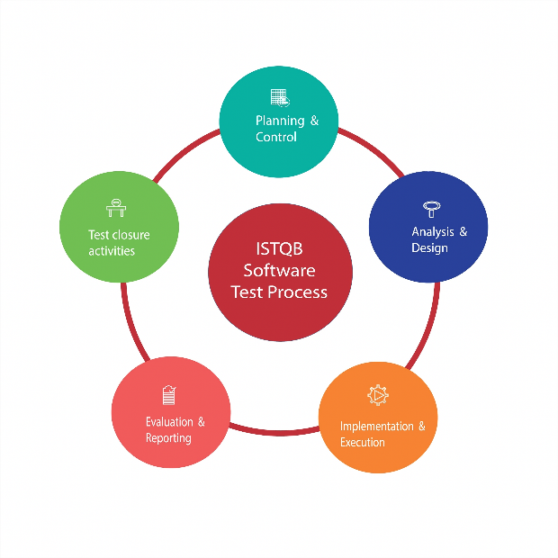
Software testing pursues two primary goals: demonstrating correctness and discovering defects. The first goal is to prove that the software satisfies all specified functional and non-functional requirements, thereby building confidence among developers, stakeholders, and customers that the system behaves as intended under normal conditions. The second, equally important goal is to deliberately uncover faults, bugs, logical errors, interface mismatches, performance bottlenecks, and security weaknesses before the product reaches users. Rather than merely showing that the software works in ideal scenarios, effective testing aggressively seeks conditions where it fails. By exposing problems early, testing enables timely correction, reduces future maintenance expenses, prevents reputational damage, and ultimately delivers a more robust, dependable product that meets both technical specifications and real-world expectations.
Q3. What is a test case? Explain the process of test case design.
A test case is a documented set of inputs, execution conditions, and expected results developed to verify that a specific feature or functionality of the software operates correctly. The process of test case design focuses on creating tests that are highly effective at revealing defects and ensuring requirement coverage. It typically involves:
- Selecting a feature or module to be tested.
- Choosing a set of input values that thoroughly exercise the feature, including normal, boundary, and invalid cases (e.g., maximum limits, zero, negative numbers).
- Documenting the expected output clearly, detailing the result the software should produce under the defined conditions.
- Optionally, including a mechanism for automated checking to compare actual and expected results.
A well-designed test case maximizes the chance of detecting hidden errors and contributes to better overall test coverage.

Q4. Explain the software testing strategy in the form of a spiral.
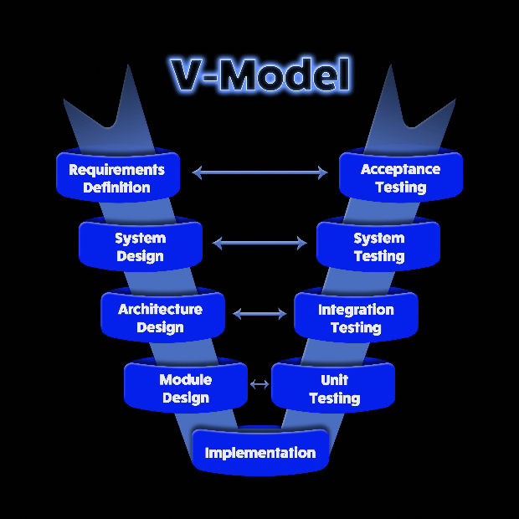
The software testing strategy is often conceptualized as a spiral model, starting with the smallest parts and systematically expanding to the complete system. This strategy ensures quality is built progressively.
- Unit Testing: At the center, individual components (functions/modules) are tested for internal logic and data correctness.
- Integration Testing: Moving outward, combined modules are tested to check interface compatibility and interaction issues.
- System Testing: Next, the fully integrated system is tested against functional, performance, security, and other non-functional requirements.
- Acceptance/Validation Testing: Finally, at the outermost level, the software is tested to confirm it meets the customer's actual needs and requirements, often involving Alpha and Beta tests.
This systematic, expanding approach reduces complexity and ensures thorough error identification at appropriate stages.

Q5. What is unit testing? Describe how it is performed.
Unit testing is the earliest and most detailed level of testing, focusing on the smallest testable parts functions, methods, or classes—in isolation. It verifies internal logic, control flow, data structures, boundary conditions, and error-handling paths within a single unit. Developers or dedicated testers write test code (often using frameworks like JUnit, pytest, etc.) to exercise every independent path, validate local data integrity, and ensure boundary values are handled correctly. Stubs, drivers, or mocks simulate dependencies. Unit tests are automated, fast, and executed frequently, ideally with every build. Because they run in isolation, defects are pinpointed quickly, feedback is immediate, and refactoring becomes safer. Strong unit test coverage forms the foundation of reliable software and drastically reduces bugs that would otherwise surface later. Unit testing is typically performed by the developer and involves:
- Isolating the unit under test using stubs, mocks, or drivers to simulate interactions with other modules.
- Executing all independent execution paths through the module at least once (code coverage).
- Testing boundary values to ensure correct results at edge limits (e.g., maximum/minimum inputs).
- Validating error-handling routines to ensure robustness.
It is frequently automated, allowing quick and repeated execution to detect defects early, which significantly reduces the complexity and cost of debugging in later phases.

Q6. Explain Integration Testing and its approaches.
Integration testing is conducted to verify the interaction and communication between software modules after they have been individually unit-tested and combined. The goal is to detect interface defects, data flow errors, and communication issues that arise when units work together as a cohesive structure.
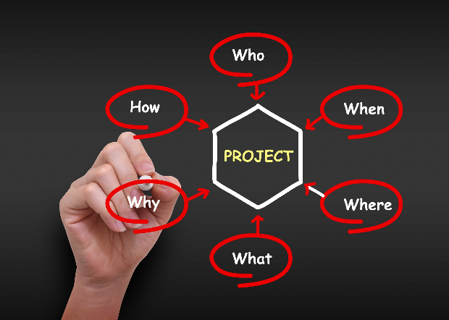
There are two main categories of approaches:
- Non-incremental (Big Bang): All modules are integrated at once and tested together. This is risky and makes error tracing very difficult.
- Incremental Integration: Modules are combined and tested step-by-step, making debugging easier. This includes:
  - Top-Down: Integration starts from higher-level control modules, using stubs for lower-level dependents.
  - Bottom-Up: Integration starts from lower-level modules, using drivers for higher-level callers.
  - Sandwich (Hybrid): Combines both Top-Down and Bottom-Up strategies.
Incremental testing is generally preferred for its systematic nature, improving stability and reliability.
Q7. Explain Alpha and Beta testing.
Alpha and Beta testing are forms of acceptance testing conducted before the final product release to gather feedback on functionality, performance, and user experience under real-world conditions. Alpha testing is performed at the developer's site by a selected group of end users or internal staff. It occurs in a controlled environment where developers can closely observe usage, monitor system behavior, and immediately log and fix issues. It primarily helps identify failures in real-user interactions and detect usability problems.
Beta testing occurs at end-user sites in their actual, uncontrolled working environments. Developers are typically not present. This phase exposes the software to unpredictable usage patterns, hardware configurations, and natural operating conditions. Users record problems and communicate feedback back to the development team. Together, they provide crucial final validation, ensuring the software is reliable and meets customer expectations before the large-scale public release.

Q8. Distinguish between White-box and Black-box testing.
White-box testing (also called structural or glass-box) requires knowledge of internal code structure, paths, and logic. Testers design cases to achieve maximum code coverage statement, branch, path using techniques like basis path testing and loop testing. It is typically performed by developers.
- Knowledge: Requires knowledge of the internal code.
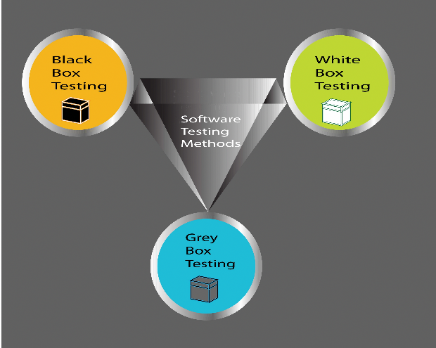
- Goal: To examine execution paths, loops, logical decisions, and internal data to ensure internal correctness, optimize performance, and achieve high code coverage.
- Who: Typically performed by developers.

Black-box testing (functional or behavioral) treats the software as an opaque box, focusing only on inputs and outputs against requirements without any knowledge of internal implementation. It is performed at unit, integration, system, and acceptance levels by independent testers.
  - Knowledge: Requires only knowledge of the specifications.
  - Goal: To provide inputs and observe outputs to verify that the system functions correctly according to its requirements.
  - Who: Typically performed by testers.
White-box excels at finding logical errors, dead code, and optimization opportunities early, while black-box ensures the product meets user expectations and specifications. Using both techniques together provide comprehensive quality assurance.
Q9. Explain System Testing and different types of system testing.
System testing evaluates the fully integrated software system to ensure it meets both functional and non-functional requirements when combined with all other system components, such as hardware, networking, and databases. Its purpose is to validate the complete system behavior in a production-like environment.
Key types of system testing include:
- Recovery Testing: Checks the system's ability to recover from unexpected failures (e.g., power loss) and restore data integrity.
- Security Testing: Verifies protection mechanisms against unauthorized access, data breaches, and system vulnerabilities.
- Stress Testing: Verifies the system's stability and performance under extreme load, high concurrency, or resource shortages (e.g., maximum number of users).
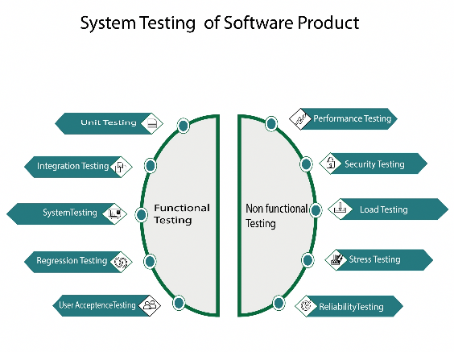
- Performance Testing: Evaluates speed, response time, and resource consumption under expected workloads.

These tests collectively ensure the overall reliability, safety, efficiency, and stability of the system.

Q10. What is Debugging? Explain the debugging process.
Debugging is the process of identifying, analyzing, and correcting errors (bugs) in software after a symptom has been detected during testing. It is the action that follows the detection of a failure. It starts when a test case fails: the symptom is reproduced, actual output is compared with expected output, and the discrepancy is analyzed. The debugger forms hypotheses about possible causes, uses tools (breakpoints, watch variables, logs, memory dumps), traces execution, and tests each hypothesis until the root cause is identified. The fault is then corrected and the fix verified through re-testing. The debugging process generally involves these steps:
- Problem Identification: A test case execution reveals a failure (a difference between expected and actual results).
- Defect Location: The debugger attempts to trace the symptom back to the specific line or section of code where the error (the root cause) resides. This is often the most challenging step.
- Analysis: The defect is analyzed to understand why it occurred and how it affects the system.
- Correction: The code is modified to eliminate the defect permanently.
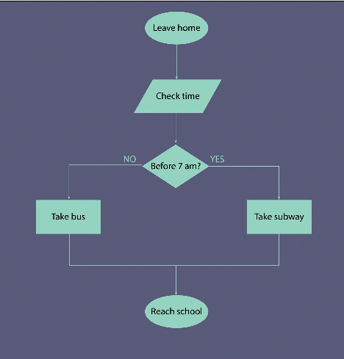
- Verification: Regression tests are run to confirm the defect is fixed and that no new errors have been introduced.

Debugging requires strong analytical skills to map a visible problem to its often-hidden root cause.
Q11. Explain debugging strategies.
Three major debugging strategies are commonly employed to efficiently locate and correct software defects:
- Brute Force: This is the most common but least efficient method. It involves collecting vast amounts of runtime information, such as register values and memory dumps, and manually scanning them for clues. It relies on simply checking every possible state or variable until the error is found.
- Backtracking: The debugger starts at the point where the error symptom was observed and traces the execution path backward through the code step-by-step. This strategy works well for smaller, contained programs but becomes overwhelmingly difficult and complex for large, multi-layered systems.
- Cause Elimination: Considered the most scientific method, it involves forming hypotheses about the possible causes of the bug. The debugger then systematically performs tests (using induction and deduction) to eliminate wrong assumptions, narrowing down the possibilities until the actual root cause is isolated.
These strategies guide the process of mapping a visible problem to its invisible source.

Q12. Why is debugging so difficult?
(Choose one)
Ans-1:
Debugging is challenging because the symptom of an error is often physically or logically far from its actual cause, making the root cause difficult to trace. Key reasons for its difficulty include:
- Symptom Distance: A failure observed in one module may be caused by an error in a completely different, interconnected module (e.g., a data corruption issue in a background process).
- Reproducibility Issues: Some defects, particularly those related to timing, concurrency, or performance bottlenecks, only appear under specific, hard-to-recreate load or environmental conditions.
- Error Masking: The symptoms of one bug may disappear when another unrelated bug is fixed, giving a false sense of security.
- System Complexity: Modern software is large, interconnected, and multi-threaded, creating an enormous number of possible execution paths and interactions to track.

Ans-2:
Debugging requires deep system knowledge, logical reasoning, and patience to overcome these inherent complexities. Debugging is often considered one of the most challenging activities in software development because the symptom of an error is usually far from its actual cause, making it hard to trace where the real problem lies. The issue detected during testing may appear in one part of the system, while the root cause exists somewhere completely different, sometimes in a hidden logical interaction or a background process. Additionally, some symptoms disappear temporarily when other bugs are fixed, making it difficult to reproduce the exact conditions under which an error occurs. Debugging becomes more complex when errors occur due to timing issues, concurrency problems, or performance bottlenecks that only appear under specific load conditions. Human factors also contribute mistakes in logic or misunderstanding requirements may not be obvious until deep inspection takes place. Modern software systems are large, interconnected, and multi-layered, so the number of possible paths to track becomes huge. Because of these reasons, debugging requires strong analytical skills, deep system knowledge, and patience, making it far more difficult than simply finding defects through testing.

Slide-9 System
Q1. What is a System in software engineering?
A system in software engineering refers to a combination of interconnected components that work together to perform a specific function or achieve a defined goal. These components include software, hardware, users, and data, all interacting within a defined environment. For example, in an online banking system, software applications manage transactions, hardware hosts the servers, users perform operations like deposits and transfers, and data maintains customer records. A system is purposeful, structured, and coordinated so that each part contributes to the overall objective efficiently. Without proper interconnection, even a small failure can disrupt the entire system.
Q2. What are the main components of a system?
A system is made up of four essential components — Software, Hardware, Users, and Data.
- Software consists of programs, modules, and services that execute the system’s functions.
- Hardware includes devices, servers, and other infrastructure required to run software.
- Users are the people who interact with the system and use it to achieve goals.
- Data represents the information that flows through the system as input, processing, and output. Together, these components form an integrated environment where each part is dependent on others to deliver the desired outcomes effectively.
Q3. Explain the key characteristics of a system.
Every system has several defining characteristics that ensure its effectiveness. A system is purposeful, meaning it’s designed to achieve a specific goal, such as processing transactions or managing information. It is structured, with an organized architecture and workflow connecting various modules. A system in system engineering is defined by several key characteristics that ensure it can function effectively and meet its goals. These include:
- Purposeful: Every system is designed to achieve specific, predefined goals, such as a banking system facilitating transactions or a ticket booking system managing reservations.
- Structured: A system possesses a defined architecture and flow, meaning its components are organized logically to work together.
- Interconnected: All parts of the system are dependent on each other; if one component fails or malfunctions, it can negatively impact the overall system's correct operation.
- Boundary-defined: A system has a clear boundary, which defines what is inside and outside of it, allowing for clear identification of its inputs and outputs.
- Operates in an Environment: The system must interact with external entities, such as users or other systems, within a defined operational environment.
Q4. What are the stages of the System Development Life Cycle?
Answer: The System Development Life Cycle (SDLC) is a process used in system engineering to plan, create, test, and deploy an information system. The stages are:
- Planning: The initial phase to define the system's scope, objectives, and feasibility.
- System Analysis: Involves gathering detailed requirements from users and stakeholders to understand what the system must do.
- System Design: Focuses on creating the blueprint for the system, including its architecture, interfaces, and data structure.
- Development (Implementation): The stage where the actual software is coded and the hardware/infrastructure is set up.
- Testing: Thoroughly verifying that the system and its components work correctly and meet all the specified requirements.
- Deployment: The process of installing the fully tested system into the production environment for end-users.
- Maintenance: The ongoing activities required to keep the system operational, including fixing bugs, updating features, and adapting to new environments.

Q5. Difference between SDLC and Software Development Life Cycle (SDLC)?
While both are processes for development, the System Development Life Cycle (SDLC) is significantly broader in scope than the Software Development Life Cycle (SDLC). Key differences:
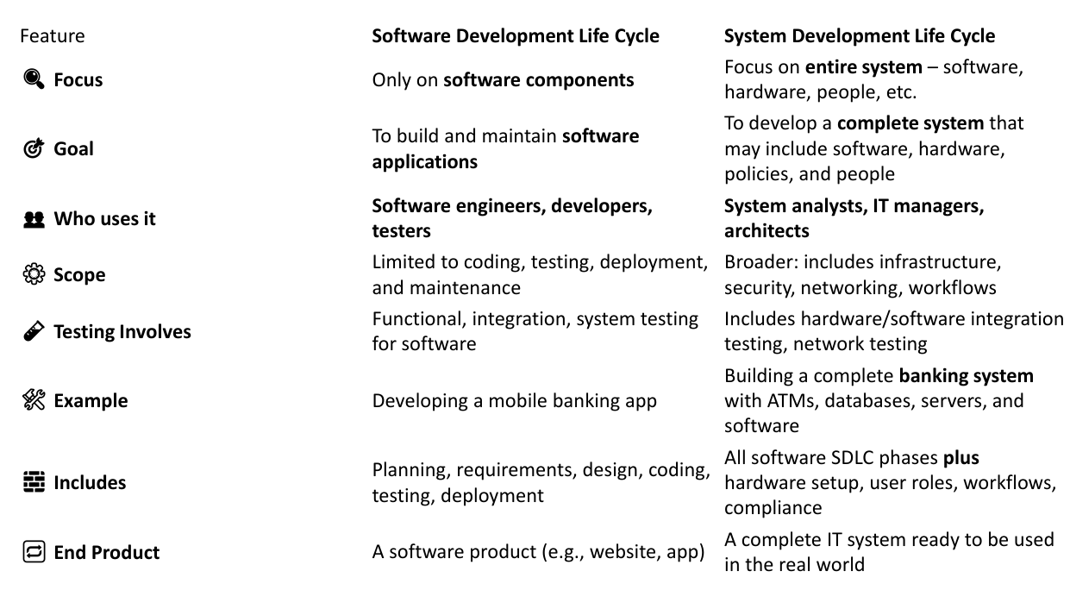

Q6. Describe the role of a System Analyst and list any four of their key responsibilities.
The System Analyst plays a crucial role as a bridge between business needs and technical solutions. They are responsible for understanding the goals of an organization and translating them into technical requirements that a development team can implement. Four key responsibilities of a System Analyst include:
- Requirement Gathering: They actively work to understand and document what the users and the business need the new system to achieve.
- Feasibility Study: They check the viability of a proposed system by assessing if it is technically, financially, and legally possible to build and implement.
- Communication (Liaison): They act as the primary point of contact and communication channel between clients/stakeholders, the development team, and other involved parties.
- System Design: They assist in designing the overall structure and logical flow of the system to ensure it meets the gathered requirements. (Other responsibilities include Problem Solving, Documentation, and Testing & Evaluation).

Q7. What is Structured Analysis in System Engineering? Name and briefly describe three common visual or modeling tools used in Structured Analysis.
Structured Analysis is a method used in system engineering to clearly understand and model a system's requirements before the actual construction begins. Its purpose is to use visual tools to break down complex systems into smaller, more manageable, and understandable parts. Three common tools of Structured Analysis are:
- Data Flow Diagram (DFD): This visual tool shows the logical flow of data through the system, illustrating how data is input, processed, stored, and output.
- Entity-Relationship Diagram (ERD): This diagram is primarily used for database design. It visually represents the system's data entities (objects or concepts) and the relationships between them.
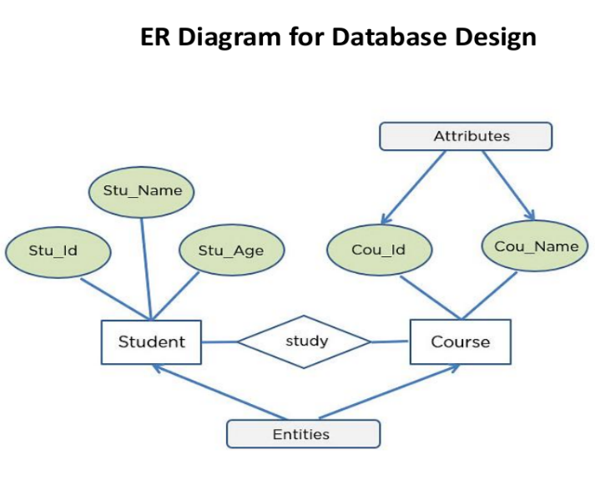

- Data Dictionary: This is a comprehensive repository that defines every data element used within the system. It includes details such as the field name, data type, format, size, and a description of its meaning.
- Process Specification (P-Spec): This is a detailed textual description that explains exactly what a specific process or functional primitive on a Data Flow Diagram (DFD) does. While a DFD shows how data flows, the P-Spec describes the internal logic or steps performed by the process. It essentially details the business rules and transformation logic that takes input data and converts it into output data.
- Decision Table: A Decision Table is a compact, tabular way to represent complex conditional logic clearly. It is highly effective for documenting logic where numerous combinations of conditions lead to various actions, ensuring all possibilities and their corresponding results are accounted for. It consists of two main sections:
- Conditions: The factors or variables that influence the decision.
- Actions: The steps to be taken based on the combination of conditions.
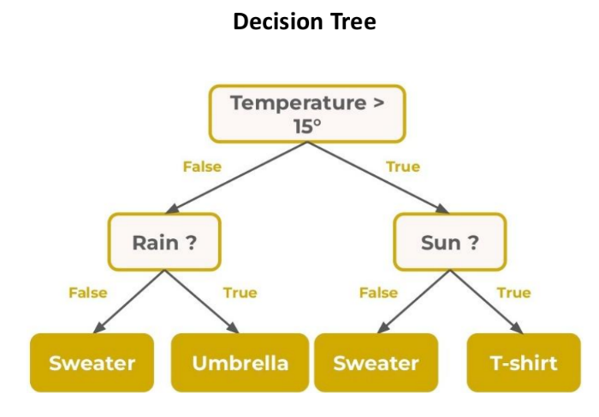

Q8. What is Cost/Benefit Analysis? Explain the main components of a Cost/Benefit Analysis.
Cost/Benefit Analysis (CBA) is a financial evaluation technique that compares the expected costs of developing a system against its potential benefits. It helps determine whether a proposed system is worth implementing. Costs include hardware, software, labor, and maintenance, while benefits may include faster processing, time savings, or better decision-making. If the benefits outweigh the costs, the system is considered feasible. CBA ensures that organizations invest resources only in projects that provide real value. The purpose of the CBA is to help management decide whether a system development project is financially and practically feasible, and therefore whether it is worth undertaking. The general rule is that the project is usually approved if the anticipated benefits are greater than the total costs. CBA involves two main components:
- Costs: These include expenditures on hardware, software licenses, developer wages, staff training, and future maintenance.
- Benefits: These are the positive outcomes such as cost savings, improved decision-making, faster processing, and higher efficiency.
The analysis compares these to find the Return on Investment (ROI). If benefits exceed costs significantly, the project is approved as financially viable and sustainable.
Q9. What is Management Information System (MIS)?
A Management Information System (MIS) is an organized system used to collect, process, and distribute data to managers for better decision-making. It integrates hardware, software, databases, and people to provide accurate and timely information. MIS plays a crucial role in planning, controlling, and coordinating business operations. For example, in a manufacturing company, MIS can track inventory levels, monitor production rates, and assist managers in scheduling new orders. It turns raw data into meaningful insights that help improve productivity and efficiency.
Purpose: The primary purpose of an MIS is to collect, process, store, and distribute relevant information throughout an organization. This synthesized information helps in three key managerial functions: planning, controlling, and decision-making at all management levels. The MIS transforms raw organizational data into meaningful reports and summaries, which are essential for tracking performance and guiding strategic direction.
Q10. Explain the components of MIS and give an example.
A Management Information System (MIS) is composed of several interconnected elements that work together to provide managers with data-driven insights for better decision-making. The main components of an MIS are:
- Hardware: This includes the physical resources necessary to run the system, such as computers and networks.
- Software: This consists of the applications and programs used for processing and transforming the raw organizational data into useful information and reports.
- Database: This is the centralized and structured repository that stores all organizational data.
- People: These are the human users of the system, including managers who use the information for planning and control, and analysts who help maintain and derive insights from the system.
- Procedures: These are the rules and policies that govern how data is handled, processed, and secured within the system to ensure accuracy and consistency.
Example: A retail company's MIS could track sales, inventory levels, and customer purchasing data. By analyzing this data, management can gain insights into product popularity, identify low-stock items that need restocking, and plan future marketing campaigns to target specific customer segments. The MIS essentially turns operational data into strategic knowledge.

Q11. What are the stages of system design?
The System Design process is divided into several stages that help plan and organize how the system will work before development starts. These stages ensure the system is clear, complete, and error-free.
- Preliminary Design:
In this stage, the overall structure of the system is planned. The main modules are identified, and the basic layout of how the system will function is decided.
- Detailed Design:
This stage explains each part of the system in detail. It defines how every module will work, what data it will use, and how it will connect with other parts.
- Interface Design:
Here, the focus is on how users and other systems will interact with the system. It includes designing user screens, forms, and communication between modules.
- Database Design:
In this stage, the structure of data storage is planned. It decides how data will be saved, linked, and managed so it can be easily used when needed.

- System Architecture:
This stage defines the hardware, software, and network setup required to make the system run properly. It ensures the system will work smoothly in real conditions.
- Review:
The final stage checks the whole design to make sure it meets the requirements. Any mistakes or missing parts are fixed before development starts.

